**PROGRAM OUTCOME ATTAINMENT**

**ANALYSIS**

**PROJECT GUIDE : SUBMITTED BY:**

**PROF. VAHEETHA SALAM VIJAYA J**

**V ABHINAND**

**ABSTRACT**

The current system involves manual calculation of Program Outcome (PO) attainment levels for each semester, subject, and batch using Excel, which is a time-consuming process. Our project aims to automate this task. The proposed system allows users to input internal marks, external marks, and the co-po matrix for each subject. Subsequently, the system will automatically calculate and output the PO attainment level for the subject.

A python code is developed to automate the calculations in excel. Users can upload co-po correlation matrix , internal marks and external marks as the input. The system will output the PO attainment level for each course outcome(CO).

**Course Outcome (CO) Assessment:**

The project provides a framework for assessing COs within the curriculum. Each subject is associated with CO-PO (Course Outcome - Program Outcome) matrices that establish the relationship between specific COs and the broader educational objectives (POs). The assessment of CO attainment includes both internal and external evaluation methods. Internal assessment criteria for COs are defined, which involve setting maximum marks and minimum achievement thresholds. Attainment levels are then assigned based on student performance, ranging from 0 (no attainment) to 3 (advanced attainment). The project also supports external assessments of CO attainment, which are typically conducted through final exams and standardized tests.

**Program Outcome (PO) Aggregation:**

The central output of this project is the determination of Program Outcome (PO) attainment levels. The project aggregates the CO-PO matrices to calculate the attainment levels for each individual PO. These attainment levels are derived from the COs associated with each PO. The attainment level for a particular PO is calculated by averaging the attainment levels of the contributing COs. The project presents the attainment levels for each PO in a clear and structured format.

This project is particularly valuable for educational institutions, curriculum designers, and accreditation bodies. It facilitates the assessment of the overall effectiveness in meeting its educational objectives and outcomes. The data-driven analysis of PO attainment assists in program improvement, accreditation processes, and transparent reporting to stakeholders.

In conclusion, this project provides a robust framework for assessing and analysing PO attainment. It serves as a valuable tool for evaluating the quality and alignment of a program with its intended educational goals, with a primary focus on the attainment of Program Outcomes specific to each course.  
This project is centred on the assessment and analysis of Program Outcome (PO) attainment. Each program spans multiple semesters, encompassing a variety of subjects, and is designed to equip students with the necessary knowledge and skills in the relative field. The primary objective of this project is to evaluate and analyse the extent to which students achieve the specified POs throughout the duration of their program, with a primary focus on determining the final PO attainment levels.

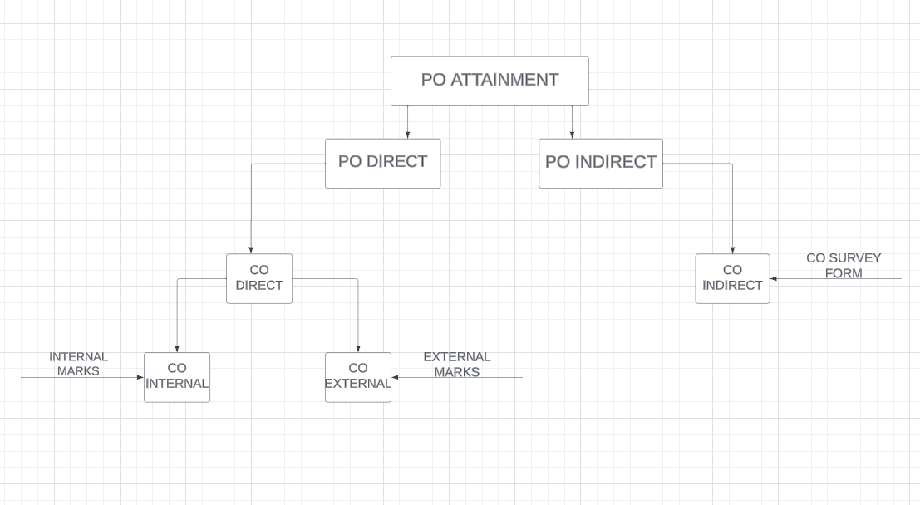

| **Calculation of PO Attainment Direct**  **Calculation of ‘CO Attainment(Internal)’ using internal assessment for a course for each CO the faculty can decide one of the following tools to compute the attainment:** | | | | | | | | | | | | | | | | | | | | | |
| --- | --- | --- | --- | --- | --- | --- | --- | --- | --- | --- | --- | --- | --- | --- | --- | --- | --- | --- | --- | --- | --- |
|  |  | | 1. Series test question | | | | | |  | |  | |  | |  | |  | |  |  | |
|  |  | | 2. Class assignment | | | |  | |  | |  | |  | |  | |  | |  |  | |
|  |  | | 3. Mini-Project | | | |  | |  | |  | |  | |  | |  | |  |  | |
|  |  | | 4. Assignment | | | |  | |  | |  | |  | |  | |  | |  |  | |
| The questions for assessing the COs should be framed in such a way that the POs mapped to the particular CO can also be assessed. | | | | | | | | | | | | | | | | | | | | | |
| Attainment Levels will 1, 2 or 3 as per the condition given below | | | | | | | | | | | | | | | | |  | |  |  | |
| Levels fixed as: | | | |  | |  |  | |  | |  | |  | |  | |  | |  |  | |
|  | Level 1: ≥50% and <60% students score more than or equal to 60% of marks | | | | | | | | | | | | | | | | | | |  | |
|  | Level 2: ≥60% and <70% students score more than or equal to 60% of marks | | | | | | | | | | | | | | | | | | |  | |
|  | Level 3 : ≥70% or more students score more than or equal to 60% of marks | | | | | | | | | | | | | | | | | | |  | |
| Using internal assessment, we will get a value 0, 1, 2 or 3 for all the CO’s | | | | | | | | | | | | | | | | | | |  |  | |
| **Calculation of ‘CO Attainment (External)’ using university exam grade for a course:** | | | | | | | | | | | | | | | | | | | | | | | |
| CO attainment level from university grades will be 1, 2 or 3 as per the condition given below. It is assumed to be same for all the COs | | | | | | | | | | | | | | | | | | | | | | | |
| Levels fixed as: | | | |  |  | |  |  | |  | |  | |  | |  | |  | | |  | |  |
|  | | Level 1 : 50% or more students score more than university average | | | | | | | | | | | | | | | |  | | |  | |  |
|  | | Level 2 : 60% or more students score more than university average | | | | | | | | | | | | | | | |  | | |  | |  |
|  | | Level 3 : 70% or more students score more than university average | | | | | | | | | | | | | | | |  | | |  | |  |

**Calculation of CO Attainment direct:**

CO direct = 0.8*CO Internal + 0.2*CO External

**Calculation of PO Attainment direct:**

PO direct = Average of CO direct for all Cos

**Calculation of PO Attainment Indirect**

**Calculation of CO Attainment Indirect:**

S – Number of “Strongly Agree”

A - Number of “Agree”

N - Number of “Neutral”

D - Number of “Disagree”

X - Number of “Strongly Disagree”

CO indirect = 1.5*((-2*X + -1*D + 0*N + 1*A + 2*S)/Number of CO)

**Calculation of PO Attainment Indirect:**

PO indirect = Average of CO indirect of all CO